Supersonic Rivet Deformation

Max Sanden & AJ Olic

ME3470 Aeronautical Propulsion

June 24, 2025

## Introduction

The goal of this project was to explore and analyze how rivet protrusions affect the aerodynamics of an airfoil at supersonic speeds. Simply put, rivets are the fasteners, like nails and screws, used to connect the multitude of different parts of an airplane. They are critical in flight, and are found all throughout an aircraft. With supersonic flight becoming increasingly more likely for commercial travel, it’s important to understand how marginal deformations affect performance. This idea stemmed from the team’s shared fascination with the Concorde, as well as learnings on several site visits to different aviation facilities. At these site visits, it became apparent how wide of a variety there was between older and newer planes when it comes to rivets. While older planes such as the Boeing B29 have large screws and rivets protruding out of part of the fuselage, more modern aircraft such as the Boeing 747 and Concorde had sleek bodies with every rivet sanded flat.

### What Killed the Concorde?

In examining the innovations that may bring supersonic commercial flight back to life, it is critical to discuss the factors that ended supersonic commercial flight in the first place. Although supersonic aircraft have existed since the late 1940s with test aircraft such as the supersonic Bell X-1, supersonic commercial flight did not appear until the late 1976 with the Concorde.[1] Jointly developed by Britain and France in the late 1960s, the Concorde was designed to be the future of air travel, shown in flight below in Figure 1.

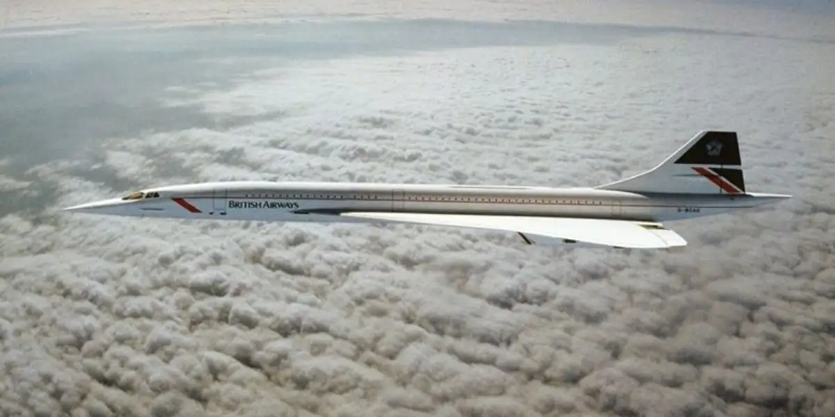

Figure 1: Concorde in flight[2]

It carried passengers between the major hubs of the western world, primarily London, Paris, and New York with a level of glamour and speed that no aircraft had achieved before. In these respects, the aircraft succeeded. It cruised at Mach 2.04 and at an altitude of 60,000ft and was by all measures an aircraft ahead of its time.[3] The financial proposition both to airlines and passengers, however, was simply not sustainable in a world driven by oil prices. The astronomical $2.8 billion (1976) development cost was jointly subsidized by the French and British governments so that airlines could buy it at an affordable price, yet even in service, the aircraft continued to provide a difficult economic proposition.[4] The Concorde had 4x the fuel burn of the Boeing 747 and yet carried a quarter of the passengers on the same cross-ocean routes.[5][6] These factors combined with a notable crash in 2000 in which 113 people lost their lives spelled the end for the jet and for supersonic air travel.[7] One company however aims to bring supersonic commercial flight back to reality by leveraging 50 years of aerospace innovation.

### Supersonic Flight in the Near Future

Boom Supersonic, founded in 2014, appears to be the company which will revive supersonic commercial aviation with their Overture aircraft.[8] Founder Blake Scholl has promised transoceanic ticket prices competitive to business class seats, on the order of $4,000 to $8,000, far more reasonable for consumers than the over $20,000 ticket prices of the Concorde.[9] On paper, the Concorde and Overture look very similar, both have slender, aerodynamic fuselages and control surfaces, highly swept delta wings, and four engines nested under the wings. The similar designs are shown below in Figures 2 and 3.[10]

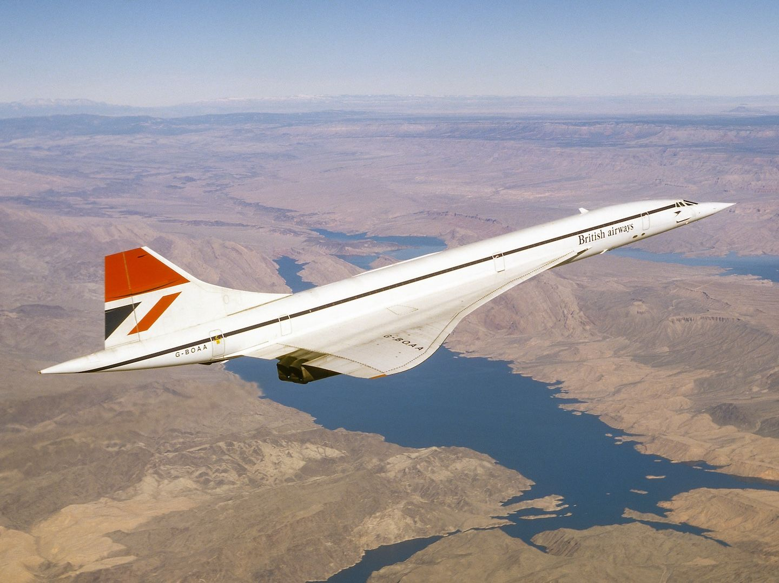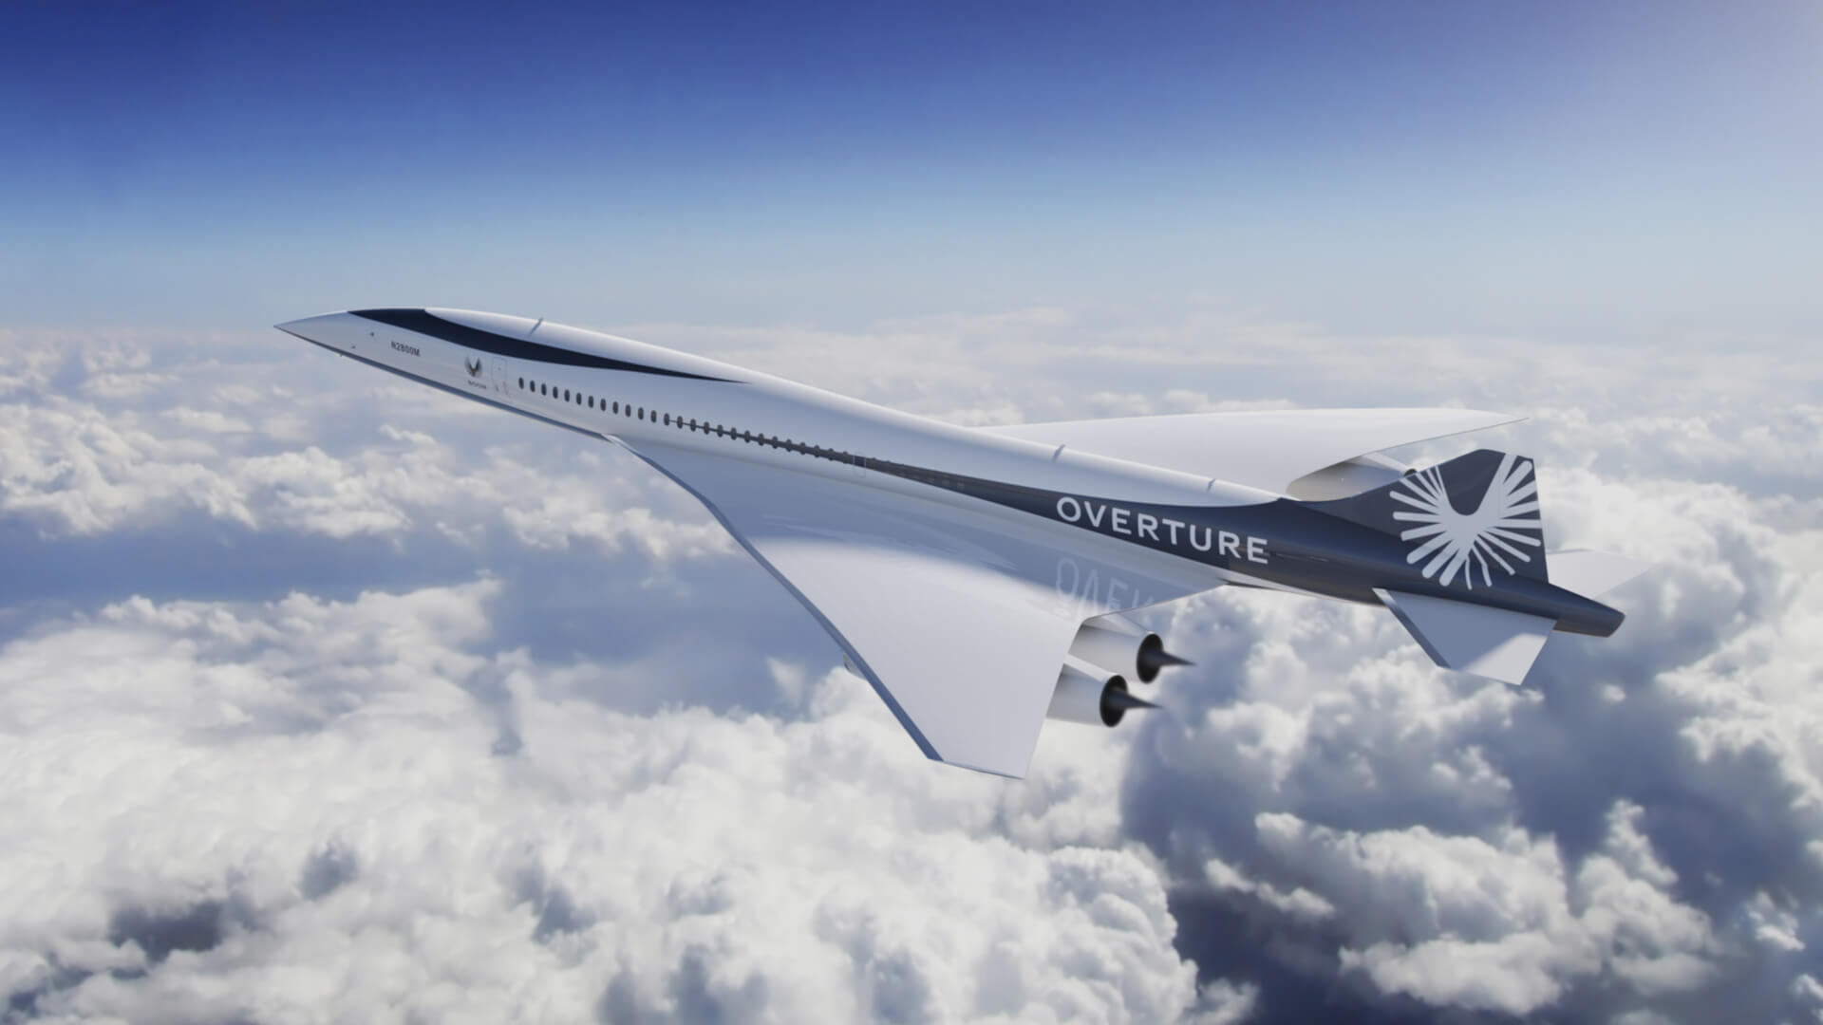

Figure 2: Concorde in Flight[11] Figure 3: Boom Overture Rendering[12]

However, as Scholl states, “Concorde was designed half a century ago with slide rules and drafting paper” whereas on the Overture, designed using modern software and Computational Fluid Dynamics simulations, “there’s hardly probably a straight line anywhere on the airplane”.[13] Today’s computer software has streamlined the design process for new aircrafts, but modern materials and manufacturing technology with aircraft majority composite materials airframes are just as important, as evident in the Boeing 787 and Airbus A350. It is these composite materials, particularly carbon fiber, which significantly reduce the frequency and prominence of micro deformations such as rivet bumps on modern airframes.

### Project Goals

In order to investigate the effects of rivet deformations on aircraft at supersonic speeds, three overall project goals were created. The general project objectives are as follows:

1. Create an Ansys simulation modelling rivets of different heights
2. Use data to analyse aerodynamic effects of rivet deformations
3. Explore how experimental results from the simulations compare to theory from class

## Background Research - Shape Effects on Airfoils Induced by Riveting

One relevant research paper by Figueira, J.A.N., Trabasso, L.G., and Silva, A.V.S explored how rivet installation can cause a wide variety of aerodynamic effects due to the airfoil deformation, modelled using sinusoidal curves.[14] Their sinusoidal modeling methodology was used because each rivet deforms the airframe downard, and between rivets the airframe is deformed upward. The cyclical nature of this pattern allows sine waves to approximately model the overall airfoil deformation. These waves were then split into the groups, short-waves, medium-waves, and long-waves. Due to rivet protrusions creating minimal deformation of around 0.01% deviation magnitude, short-waves were the primary focus.

Testing was conducted using XFOIL, a software suitable for analysis at subsonic speeds. The testing criteria include angle of attack, from 0° to 5°, mach numbers of 0.0, 0.3, 0.5, and 0.7, and the Reynolds Numbers of 3E5, 3E6, and 3E7. Modification of these parameters created data regarding lift and drag coefficients. With the focus on rivet protrusions, short waves were exclusively examined.

Analyzing their results, the short-wave deformation had a marginally positive effect on the lift coefficient. This was likely due to the angle of attack being set to 3°, which in turn led to the lower rivets having a greater effect as compared to the upper rivets, confirmed with the airfoil being symmetrical. When reviewing the drag, as seen in Figures 4 and 5, there was minimal effect on the pressure drag coefficient. This can be explained by subsonic speeds, which do not produce shock waves. There was a significant increase in the friction drag coefficient, which can be primarily explained in two ways. There may have been inaccuracies in the software, where a small sinusoidal wave greatly increased the total length of the airfoil, thus adding additional surface area for friction to act. Alternatively, the small bumps may also have significantly disrupted the airflow, creating a turbulent effect which in turn increased the drag. The results of their paper can be found below in Figures 4 and 5.

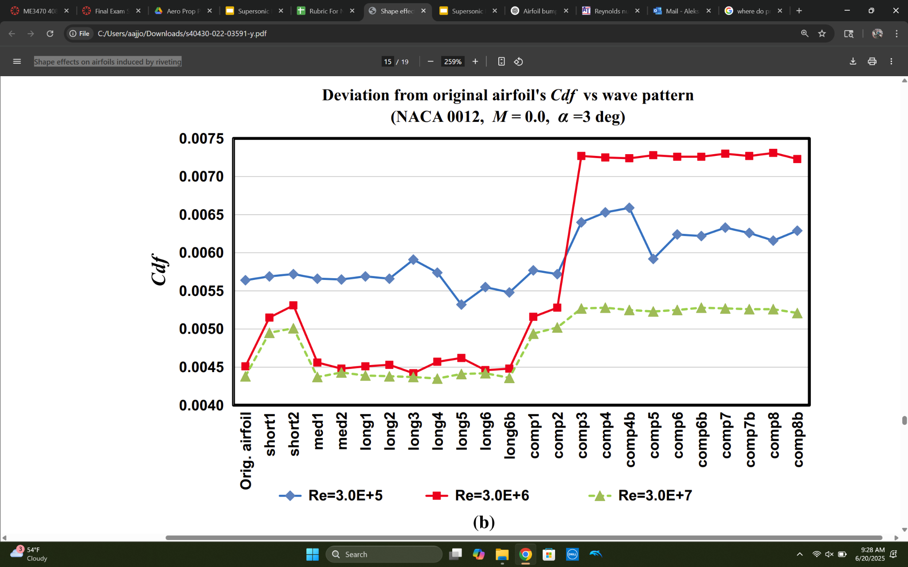

Figure 4: Derivation from original airfoils C*df* vs wave pattern.

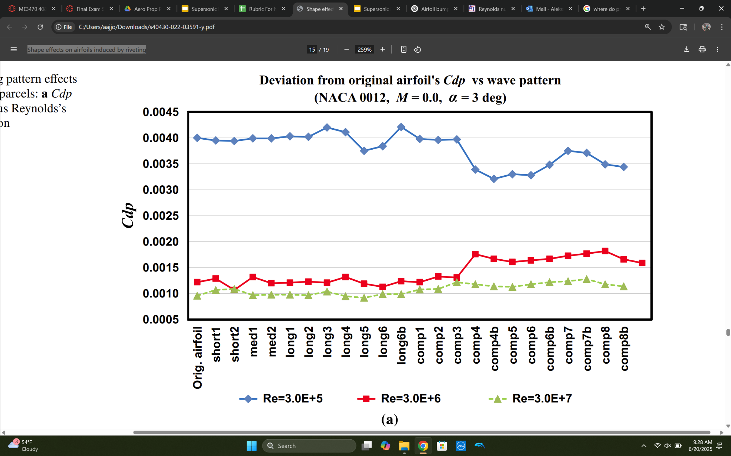

Figure 5: Derivation from original airfoils C*dp* vs wave pattern.

Supersonic modelling will likely yield similar results. The lift coefficient should increase due to higher speeds, as should the friction drag coefficient. Regarding the pressure drag coefficient, it is difficult to predict how it will change at supersonic speeds. The additional bumps may create additional shock waves, decreasing the performance of the airfoil. There is also a possibility that the protrusions act as a set of oblique waves that diffuse the shock wave along the airfoil.

The shortcomings of this paper primarily stem from its large scope. By analyzing such a wide variety of rivet deformations, there was less focus on individual aspects. Additionally the constraints regarding XFOIL, and its limit to subsonic speeds made the results less applicable to future research, along with the results at higher mach numbers being less reliable. The airfoil chosen, the NACA 23012, is also a relatively unrealistic airfoil for commercial travel, negatively impacting the relevance of results.

To solve this, testing of supersonic rivet aerodynamic effects will be done in Ansys, allowing for simulations at higher mach numbers. Ansys will also allow more precise airfoil geometry, as the geometry can be directly imported. With a focus exclusively on rivet protrusions, each individual rivet can be added to create a highly accurate simulation. With these design choices, testing can be done at specific supersonic conditions, reflecting the actual cruising conditions of the Concorde or future supersonic aircraft.

## ANSYS Modelling

### Initial Simulation Plan

The simulation would use the NACA 0003 airfoil, where the geometry was found using the Airfoil Tools database.[15] The NACA 0003 is a camberless airfoil design with a maximum thickness of 3.5% relative to the overall length, located at 30% of the chord, the distance from tip to tail. This airfoil was chosen due to its reasonable approximation for supersonic airfoils, which generally have extremely low thickness to chord ratios and little or no camber. This is contrasted with the supercritical airfoils seen on most subsonic commercial aircraft of the 21st century. Two hypothetical sections of the airfoil were examined. Section A, located near to the fuselage, would have a chord of 24.384m corresponding to the chord at 10% span on the Concorde. This section would have a lower relative prominence of the rivets compared to the overall wing size; therefore the rivets would have a smaller effect on the overall airfoil performance as compared to the ideal, smooth airfoil. Section B, located near the tip of the wing would have a chord of 6.096m, corresponding to the chord at 80% span on the Concorde.[16] This section would have greater relative rivet prominence and therefore a larger observable performance discrepancy as compared to the ideal smooth airfoil. Sections A and B can be found depicted on an illustration of the Concorde in Figure 6 below.

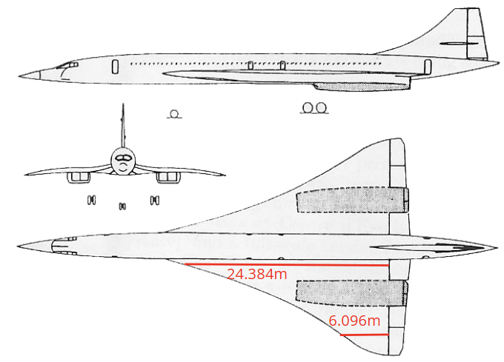

Figure 6: Initial sections for simulation.[17]

Following these two airfoil selections, a number of assumptions had to be made to perform the Ansys simulation.

### Ansys Assumptions

Simulating the effect of rivet deformations on airfoil performance required a number of assumptions to be made in order to limit the scope of the research project.

1. 2-Dimensional Flow

The assumption of 2-Dimensional flow was primarily due to time constraints. 2D simulations generally take a couple of seconds up to 30 minutes within Ansys, depending on the complexity of the shape and the number of simulation iterations specified. 3D simulations take hours or even days on very powerful computers to generate results. Given these hardware and time limits, 2D simulation was chosen for rivet deformation analysis.

1. Cruising conditions

The assumption of cruising conditions was chosen for several reasons. Firstly, it is the primary flight regime at which a supersonic airliner spends the majority of its time, at high altitude and high Mach number. The cruising flight regime is where the majority of fuel savings are made, and therefore the flight regime for which the Concorde was optimized. Additionally, the assumption of cruise conditions limited the number of variables affecting the change in performance metrics between an airfoil with rivet deformations and one without. At low speeds such as during takeoff and landing, the delta wings used on supersonic aircraft develop the majority of their lift using vortices, which were beyond the scope of a 2D simulation and which might confound any observable effect of rivet bumps on overall performance.

1. Even rivet spacing and consistent rivet prominence

Consistent rivet spacing and consistent rivet prominence were made due to difficulty finding precise rivet information relating to the Concorde online. Neither the rivet spacing nor location were publicly available, and the protrusions can vary by rivet. It was necessary to make the simplifications of even rivet spacing with equal rivet prominence across the length of the airfoil.

### Modeling Issues

After laying out the project goals and simulation plan, airfoil sections A and B described above were then designed in AutoCAD to be imported into Ansys for analysis. From this point forwards, numerous issues were faced with all of the different softwares used. Firstly, geometry in AutoCAD couldn’t be directly imported into Ansys for analysis, necessitating the migration of the design phase from AutoCAD into Ansys. Once the airfoil was designed, the boundary box through which air would flow in the simulation couldn’t be created for either section A or B. Both airfoils were too large for a boundary box to be created, one which would leave enough space to prevent boundary-airfoil interaction. Once solved, problems with the meshing led to inconsistent patterns, creating inconsistent pressure gradients and velocity profiles within the simulation itself, as seen in Figure 7. All of these problems necessitated some significant simplifications of the Ansys simulation plan.

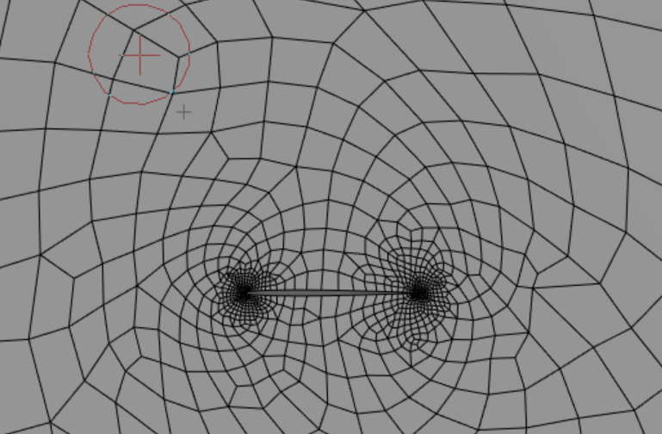

Figure 7: Mesh of rivetless airfoil.

### Second Simulation Plan

The multitude of problems in executing the initial simulation plan necessitated a redesign of the simulation. In the second attempt only one airfoil section was to be examined, a section with a chord of 1m. The reduction in airfoil size would simplify the overall design process, alleviate the boundary box and meshing issues, and reduce the time to conduct multiple simulation iterations. Even with these simplifications, numerous errors were encountered at each step of the design, meshing, and simulation processes, but eventually the simulation was successfully completed for a 1m chord wing section at supersonic conditions, shown below in Figure 8.

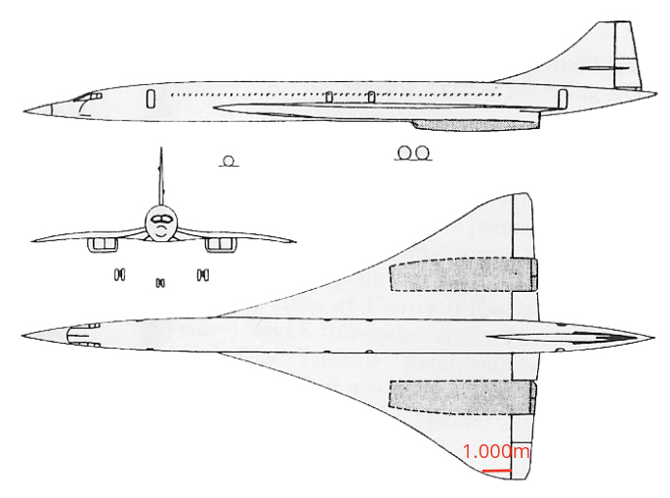

Figure 8: Updated section.[18]

## Results

In order to emulate the cruise conditions of the Concorde, simulations were conducted at a temperature of 217K, at an air pressure of 7170Pa, and mach number of 2.04.[19] By using these parameters, a reasonable approximation of the shockwave behavior and overall aerodynamic effects that the Concorde experienced could be made, all with the goal of analyzing how rivet deformations affect performance.

### No Rivets and Solid Wall Boundary Conditions

The first simulation was iterated 5000 times until residual convergence leading to more precise results. Mistakenly, the top and bottom surfaces of the boundary box were set as solid walls rather than pressure outlets, leading to the shockwave reflections seen below. Nevertheless, the general in-class theory of supersonic flow over an airfoil was verified within this first simulation. The oblique shockwaves formed on the leading and trailing edges of the airfoil were observed and had the straight-line behavior expected for shockwaves when analyzed in a 2D plane. The expected pressure increase and velocity drop following the shockwaves were observed, as well as the turbulence generated behind the shockwaves and within the wake of the airfoil as a whole. This can be clearly seen in Figures 9, 10, and 11.

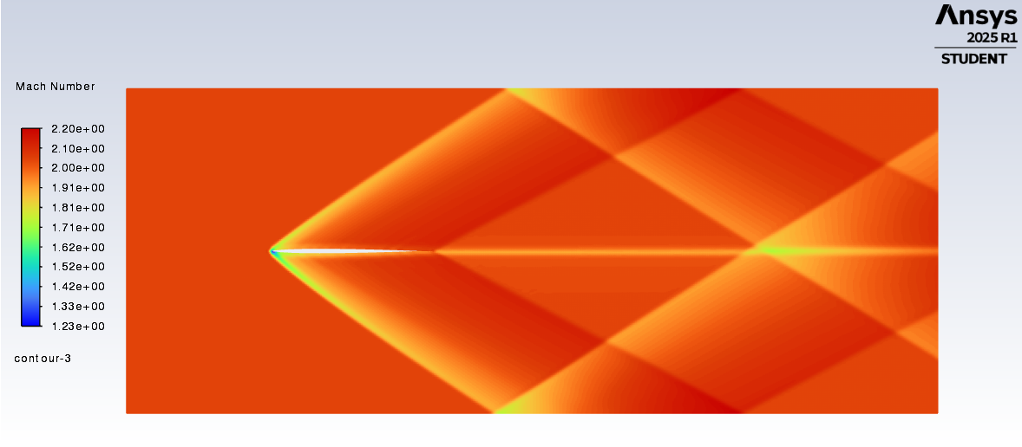

Figure 9: Mach number.

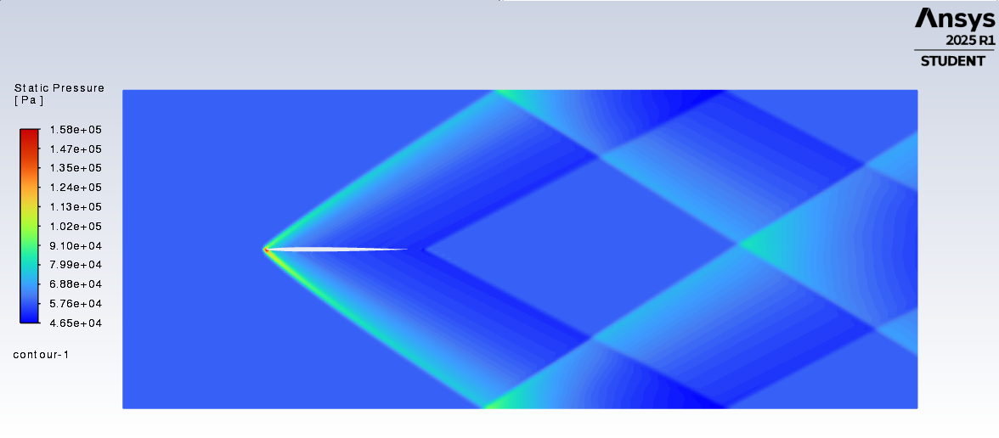

Figure 10: Static pressure.

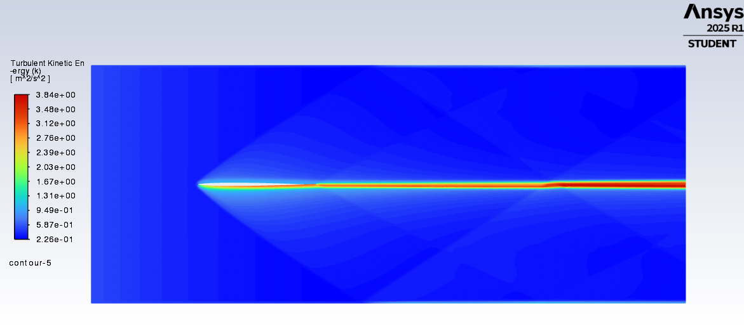

Figure 11: Turbulent kinetic energy.

A further visual analysis was performed which showed the velocity streamlines around the airfoil. Over 300,000 particles were tracked which enabled the observation of stagnation point behavior at the leading edge of the wing, where velocity approaches zero while the temperature, pressure, and density approach their respective stagnation values.

Despite the interesting results seen in the first simulation, as the boundary conditions were not correctly set, the results would not be valid for the analysis of rivet deformation aerodynamic effects. The results are shown below in Figures 12 and 13.

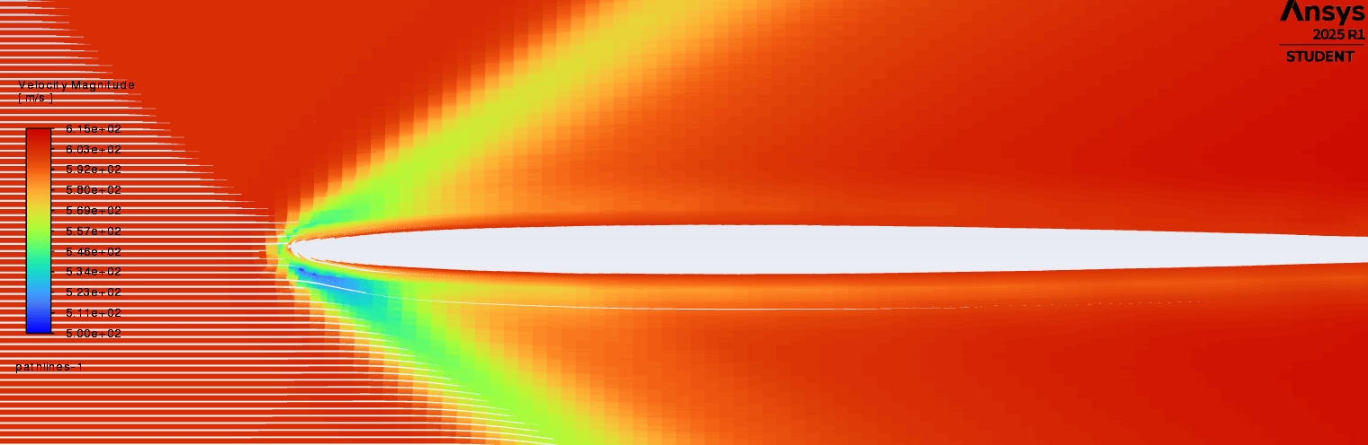

Figure 12: Velocity magnitude.

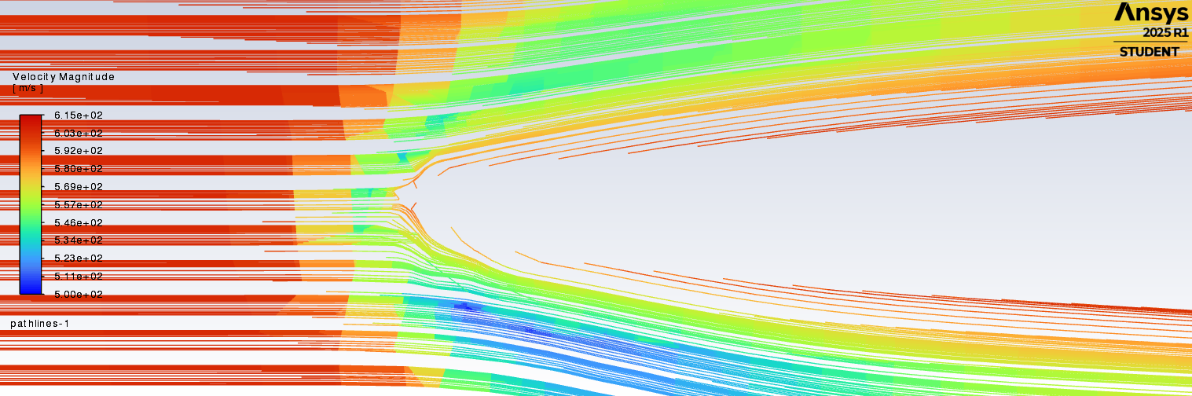

Figure 13: Velocity magnitude close-up.

### No Rivets and 3-Sided Outlet Boundary Conditions

The second simulation was performed with a slight change to the boundary conditions in which the left side of the bounding box was made the velocity inlet, while the top, bottom, and right sides were set as outlets. Once again, this combination of boundary conditions did not produce the desired results, but these conditions did yield some interesting visuals regarding the velocity, pressure, and temperature contours. Due to the 3-sided outlet conditions, a strong pressure gradient was observed at the inlet, confounding results once again. This pressure gradient did however create interesting behavior with respect to the shockwaves, which appeared to curve as they entered the low pressure regions near the outlet. Contours of mach number and static pressure are shown below in Figures 14 and 15.

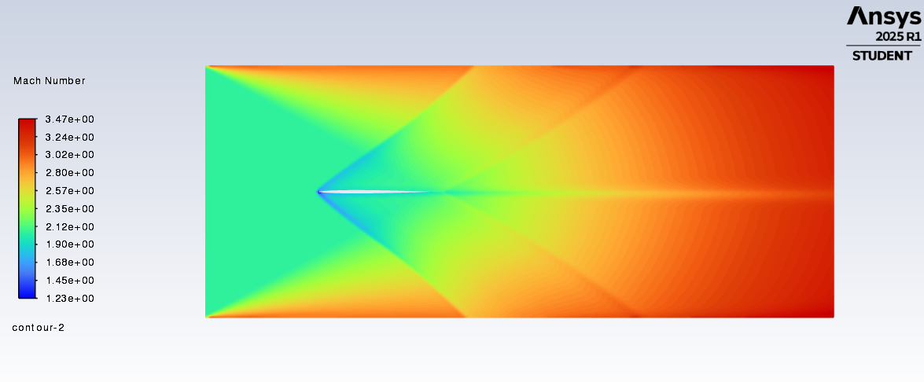

Figure 14: Mach number.

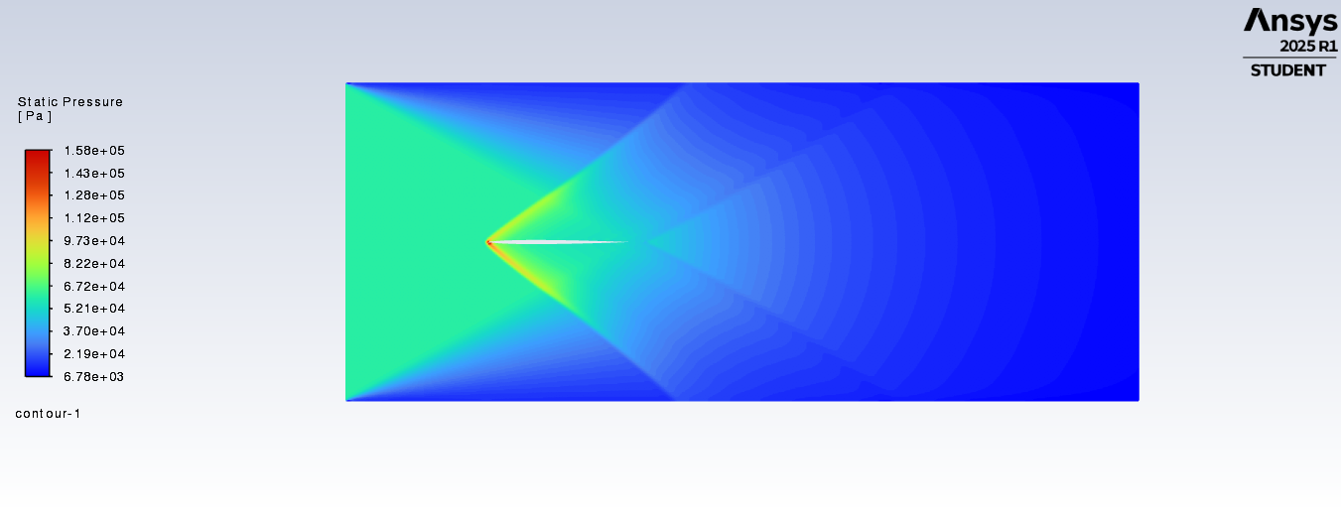

Figure 15: Static pressure.

It would have been difficult to make any meaningful comparisons between riveted and rivetless airfoils with these incorrect boundary conditions, so another simulation was required to accurately simulate the supersonic flow.

### No Rivets and Correct Boundary Conditions

Two changes were made in the final simulation. Firstly, the inlet was changed from pressure based to density based, which would create more accurate results at supersonic speeds when the working fluid, air, becomes highly compressible. Secondly, the boundary conditions were changed such that all boundaries were combined inlets and outlets, preventing the pressure gradients and boundary interactions observed in the previous two iterations.

The final simulation provided the expected flow visualizations around a supersonic airfoil. Both the leading and trailing edge shockwaves forming on the airfoil could be observed due to velocity, pressure, density, and temperature changes. Furthermore, the boundary layer around the airfoil could now be observed. Near to the airfoil surface, temperature and pressure increased, while the mach number decreased, consistent with the no-slip boundary condition. Turbulence also increased when moving from tip to tail of the airfoil as the boundary layer grew thicker and flow transitioned from laminar to turbulent. The correct boundary conditions contours for mach number, static temperature, and turbulent kinetic energy are shown below in Figures 16, 17, and 18.

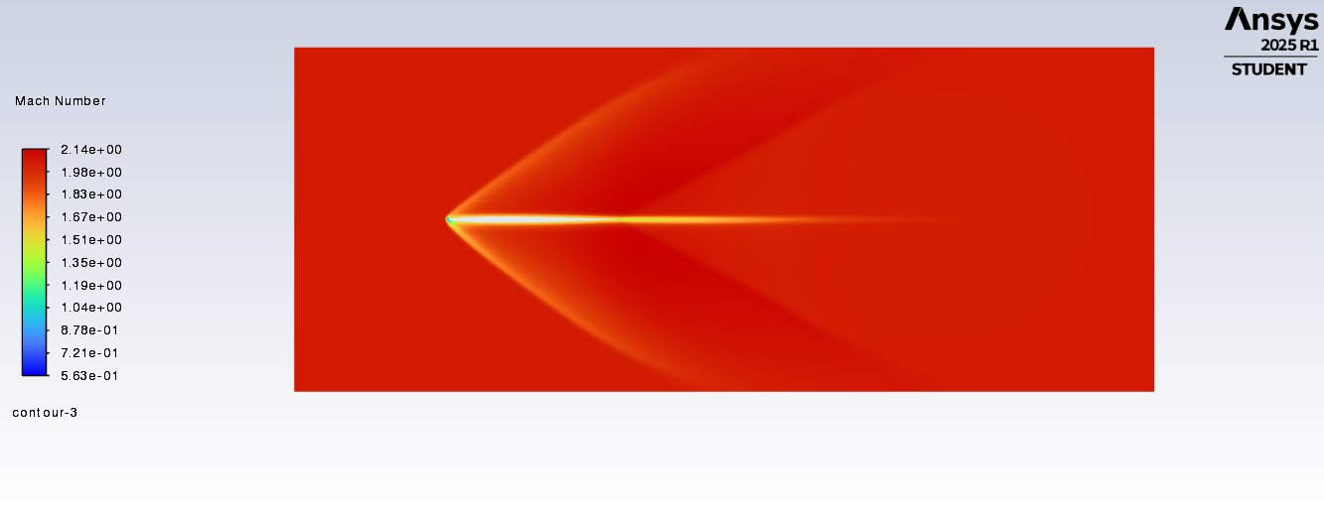

Figure 16: Mach number.

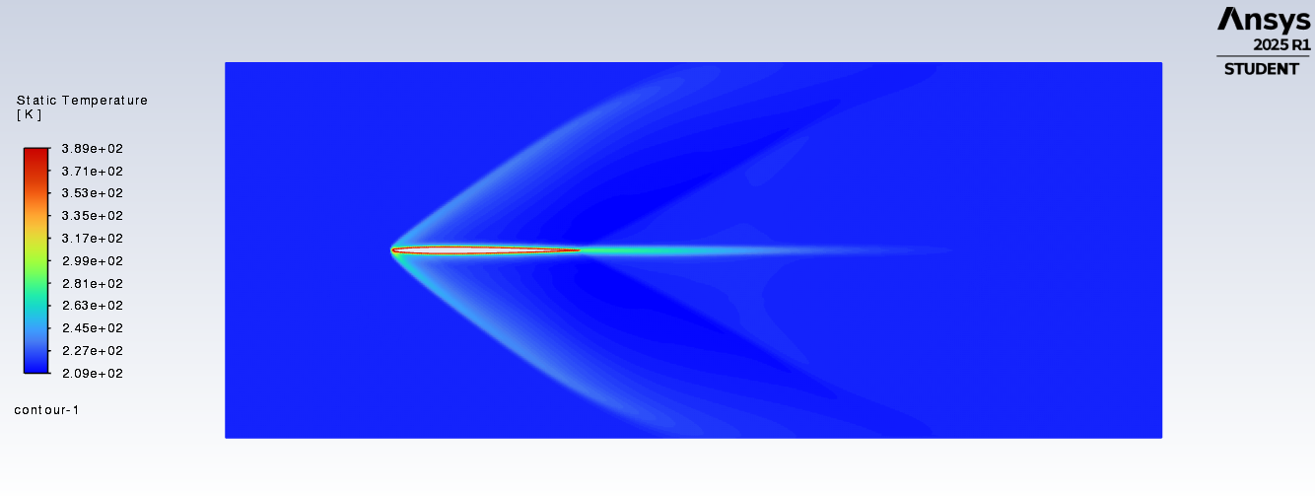

Figure 17: Static temperature.

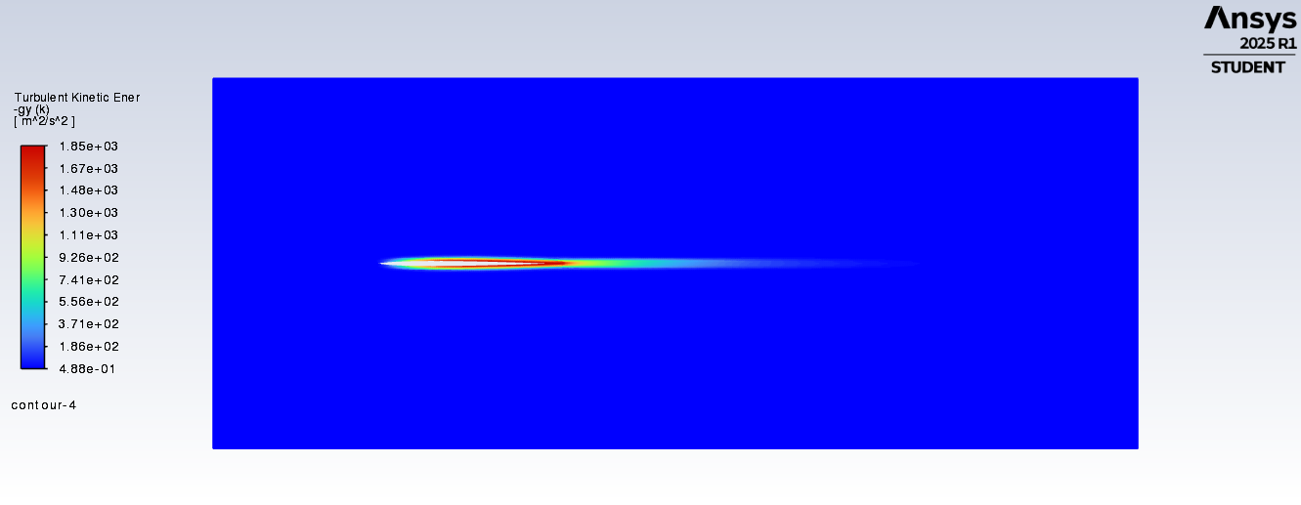

Figure 18: Turbulent kinetic energy.

As with the first simulation, a further visual analysis of the velocity was performed which showed the stagnation point behavior. At the very tip of the airfoil, velocity approached zero as air was diverted above and below the airfoil. Once again however, the meshing precision limited the precise observation of the stagnation point, and future simulations studying the specific stagnation location would require a greater meshing precision. The velocity vector contour is below in Figure 19.

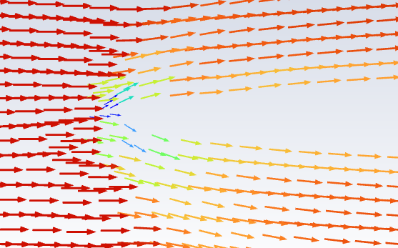

Figure 19: Velocity potential vectors.

### Modelling with Rivets

To model the airfoil with the rivet protrusions, the NACA 0003 was once again used, with an array of rivets added within AutoCAD. Ideally, this would have been an uneventful process, where the modified airfoil could be directly imported into Ansys, then simulated with identical parameters. This unfortunately was not the case. In AutoCAD, the initial airfoil and rivet array were both considered arcs, which meant they acted as reference geometry within Ansys. To allow import, every individual line needs to be considered a polyline, where it is a sum of straight lines all in relation to the origin. Converting these arcs was a difficult process due to the rivet endpoints not terminating at the airfoil. To solve this, the airfoil had to be manually broken between every individual rivet. This then allowed the excess rivet segments to be trimmed, creating one uniform body. Still, an exported .IGS file was insufficient for Ansys. The solution needed to be exported into Solidworks as a mediary software. Below in Figure 20 is the AutoCAD riveted airfoil model which was exported into Solidworks.

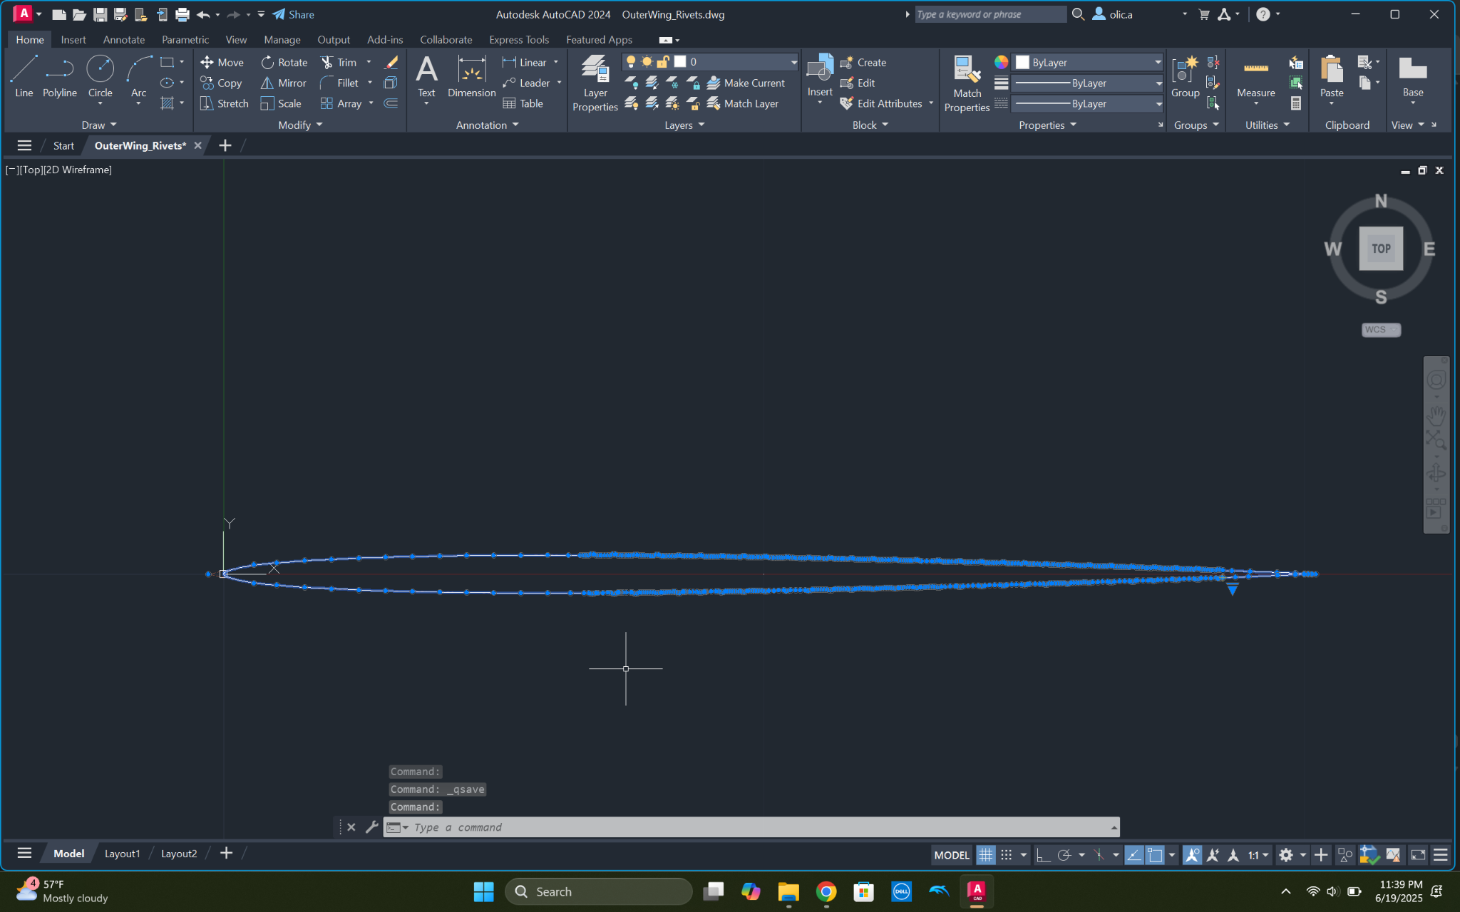

Figure 20: Autocad model of airfoil with rivets.

In Solidworks, the process was less tedious, yet still not ideal. Solidworks did not allow .dwg files to be exported as a coordinate system. Instead, the AutoCAD drawing could be imported as a part, and then a copy of the drawing could be extruded. This 3D geometry was the only workaround that was successful in importing accurate geometry into Ansys.

Even so, Ansys was still resistant to this plan. Throughout this whole process, countless file types were not supported within ansys. Once the 3D body was opened in ProjectManager, it was difficult to get an acceptable wind tunnel. Since testing was done exclusively in 2D, the software struggled to integrate a 3D body. This was mitigated by suppressing the 3D body, and creating a surface on one of the faces. From there, it was relatively simple to create the boundary box using a boolean subtraction. It was difficult to create a mesh that accurately reflected the rivet protrusions, while not becoming overly complicated. This was solved by creating a fluid mesh that had complex geometry along the airfoil, and simpler geometry further away, shown below in Figure 21.

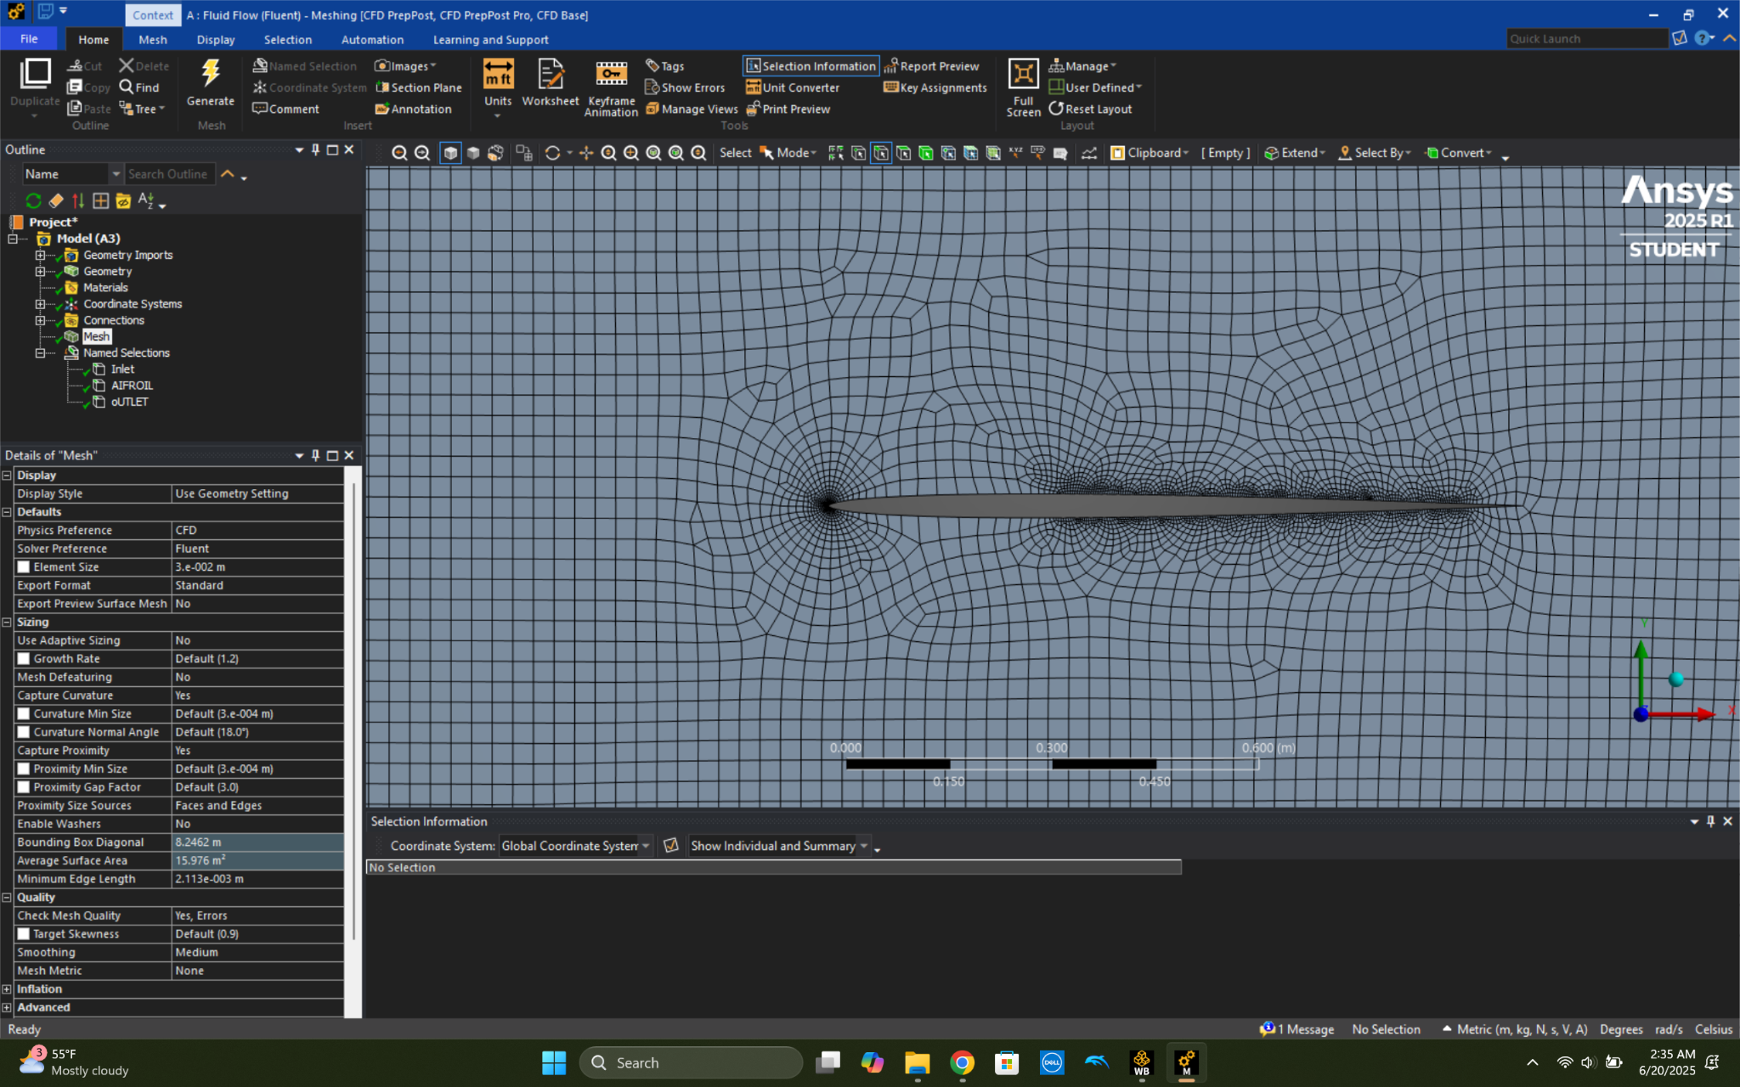

Figure 21: Mesh of airfoil with rivet protrusions.

Unfortunately, at this point it was no longer possible to proceed with Ansys. This was likely due to a licensing error, but the software no longer supported the design. The student license has limitations on the complexity of allowed geometry. Simplifying both the original model as well as the mesh both proved unsuccessful. Because of this, it was not possible to simulate how rivet deformation affects the aerodynamics of an airfoil.

## Conclusion and Learnings

### Know The Software, Limit the Project Scope

Although the rivet deformation project generated some interesting learnings in the area of supersonic airflow over airfoils, difficulties arose from start to finish in the execution of the originally stated project goals. Ultimately, the team learnt far more about how to structure research projects in the future as compared to how much was learnt in the research project itself. Ultimately, two key pieces of advice were extracted regarding the approach towards research projects which utilize simulation software such as Ansys.

1. Research projects must have very limited scope

Initially, this project sought to examine more than 10 permutations of rivet bumps on airfoils. Ideally, rivet prominences would have been analyzed, different size airfoils would have been analyzed, different angles of attacks would have been analyzed, all in all summating to a deep understanding of the effects of rivet deformities on supersonic airfoil performance. However, it quickly became apparent that within the time and software constraints, to analyze all of the above variables would have been impossible. The team’s recommendation would be that in future research projects, manipulatable variables should be limited from the very start in order to maximize high quality data within a small area. Although learnings in the rivet deformation project may be wide ranging, it is hard to draw any specific conclusions regarding the key project goal of analyzing aerodynamic effects of the rivet deformations themselves.

1. Software cross-compatibility issues are frequent and must be considered from the start

The initial project plan necessitated the use of AutoCAD to do the airfoil design before importing into Ansys for the meshing and analysis portions of the simulation. Over time, it became apparent that SolidWorks was necessary to aid in the porting of designs into Ansys. The use of all three softwares created cascading issues with importing and exporting files, incompatible drawings and designed parts, and complex shapes which one software or another was not capable of rendering. In hindsight, the ideal approach would have been to utilize just one software to limit cross-compatibility issues and to maximize proficiency within the given software.

### Final Learnings

Despite failing to make meaningful conclusions regarding the aerodynamic effects of rivet deformations at supersonic speeds, several in-class learnings were validated.

Firstly, the stagnation point behavior expected for airfoils was observed. At the leading edge of the airfoil, visual analysis in Ansys showed the expected increases in temperature, pressure, and density that occur at a stagnation point. To mathematically analyze each of these values would require a more focused project examining just the airfoil tip, requiring a more precise mesh and smaller boundary box. The equations for stagnation properties are shown below in Figure 20.

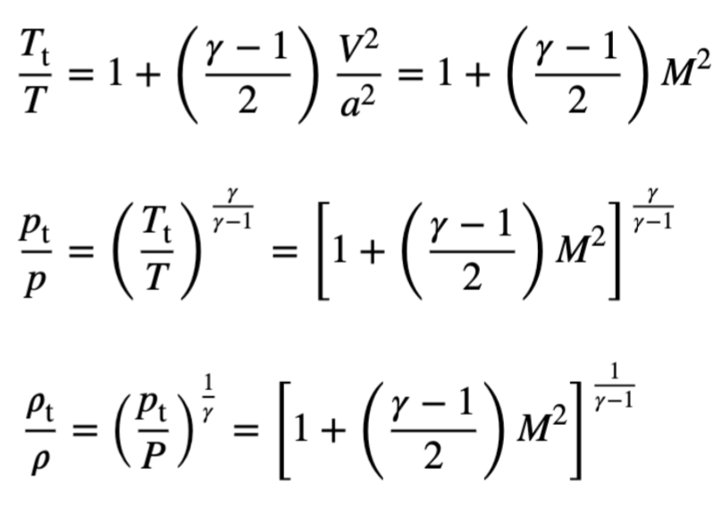

Figure 20: Stagnation point relationships.[20]

Secondly, the behavior of oblique shockwaves developing off of slender bodies were visually observed within the Ansys simulation. In-class theory predicted the formation of these shockwaves given the sharp tip of the airfoil and low thickness to chord ratio, and in-class examples using schlieren imaging of an X-15 in flight show the same shockwaves forming, shown below in Figure 21.

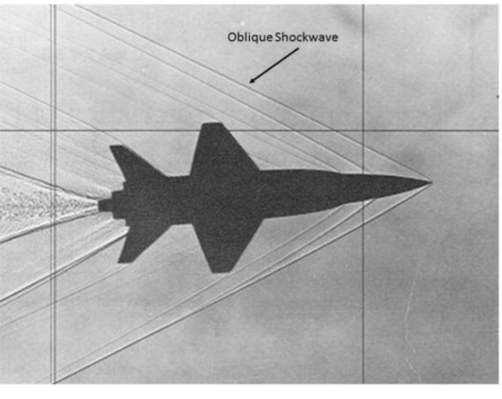

Figure 21: Oblique waves on X-15.[21]

Finally, an unintended learning came in the form of the first simulation, where the top and bottom boundaries were walls rather than outlets. In this simulation, the shockwaves were seen reflecting off of each wall while simultaneously dissipating. Although not relevant to the effect of rivet deformations at supersonic speeds, the reflecting shockwave behavior does lend insight into shockwave reflections within an engine inlet, as shown below in Figure 22.

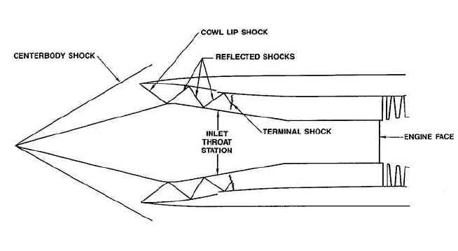

Figure 22: Engine intake.[22]

## 

## Bibliography:

“An Interview with Boom Founder Blake Scholl About Building a Supersonic Airliner.” *Stratechery by Ben Thompson*, 22 June 2023, https://stratechery.com/2023/an-interview-with-boom-founder-blake-scholl-about-building-a-supersonic-airliner/.

“---.” *Stratechery by Ben Thompson*, 22 June 2023, https://stratechery.com/2023/an-interview-with-boom-founder-blake-scholl-about-building-a-supersonic-airliner/.

*Bell X-1 Glamorous Glennis | National Air and Space Museum*. https://airandspace.si.edu/collection-objects/bell-x-1/nasm_A19510007000. Accessed 24 June 2025.

“Boom - Farnborough - FlyBy - Boom Supersonic Accelerates Overture Aircraft and Engine Development.” *Boom*, 23 July 2024, https://boomsupersonic.com/flyby/boom-supersonic-accelerates-overture-and-engine-development-farnborough-airshow.

“Boom - Overture.” *Boom*, https://boomsupersonic.com/overture. Accessed 24 June 2025.

*Concorde | Summary, History, & Facts | Britannica*. 22 June 2025, https://www.britannica.com/technology/Concorde.

“Concorde: The Story of Supersonic Passenger Flight.” *NMS*, https://www.nms.ac.uk/discover-catalogue/concorde-the-story-of-supersonic-passenger-flight. Accessed 24 June 2025.

“Concorde Wing.” *Heritage-Concorde*, https://www.heritageconcorde.com/the-wing. Accessed 24 June 2025.

“Did the Concorde Have Flat Plate Airfoil?” *Aviation Stack Exchange*, Stack Exchange Inc, 2023, https://aviation.stackexchange.com/questions/95760/did-the-concorde-have-flat-plate-airfoil.

Figueira, José Augusto Nunes, et al. “Shape Effects on Airfoils Induced by Riveting.” *Journal of the Brazilian Society of Mechanical Sciences and Engineering*, vol. 44, no. 7, July 2022, p. 285. *DOI.org (Crossref)*, https://doi.org/10.1007/s40430-022-03591-y.

Hayward, Justin. “How Much Did Each Concorde Plane Cost New?” *Simple Flying*, 18 Jan. 2022, https://simpleflying.com/concorde-cost-new/.

Hayward, Justin, and Sumit Singh. “How Much Fuel Did Concorde Consume?” *Simple Flying*, 16 Feb. 2022, https://simpleflying.com/concorde-fuel-consumption/.

Lakritz, Talia. “I Toured a Concorde. Take a Look inside the Discontinued Supersonic Commercial Jet Flown by Celebrities and Royals.” *Business Insider*, https://www.businessinsider.com/concorde-supersonic-plane-tour-photos-2024-10. Accessed 24 June 2025.

Leone, Dario. “Not a Single Photo of Concorde Flying at Mach 2 Exists. Here’s Why.” *The Aviation Geek Club*, 12 Aug. 2021, https://theaviationgeekclub.com/not-a-single-photo-of-concorde-flying-at-mach-2-exists-heres-why/.

Ma, Ruidong. *Chapter 2. Compressible Flow with Friction and Heat: A Review*. https://northeastern.instructure.com/courses/215045/files/folder/Lecture%20Notes/Chapter%202?preview=34903829. Northeastern University.

*NACA 4 Digit Airfoil Generator (NACA 0003 AIRFOIL)*. http://airfoiltools.com/airfoil/naca4digit?MNaca4DigitForm%5Bcamber%5D=0&MNaca4DigitForm%5Bposition%5D=0&MNaca4DigitForm%5Bthick%5D=3.5&MNaca4DigitForm%5BnumPoints%5D=81&MNaca4DigitForm%5BcosSpace%5D=0&MNaca4DigitForm%5BcloseTe%5D=0. Accessed 24 June 2025.

*U.S. Standard Atmosphere: Temperature, Pressure, and Air Properties vs. Altitude*. https://www.engineeringtoolbox.com/standard-atmosphere-d_604.html. Accessed 24 June 2025.

Wells, Sarah. “How Did the Concorde Fly so Fast?” *Live Science*, 10 Nov. 2024, https://www.livescience.com/technology/engineering/how-did-the-concorde-fly-so-fast.

1. “Bell X-1 Glamorous Glennis | National Air and Space Museum”
2. Leone
3. “Concorde | Summary, History, & Facts | Britannica”
4. Hayward
5. Lakritz
6. Hayward
7. “Concorde”
8. “Boom - Overture”
9. “An Interview with Boom Founder Blake Scholl About Building a Supersonic Airliner”
10. “Boom - Overture”
11. Wells
12. “Boom - Farnborough - FlyBy - Boom Supersonic Accelerates Overture Aircraft and Engine Development”
13. “An Interview with Boom Founder Blake Scholl About Building a Supersonic Airliner”
14. Figueira et al.
15. NACA 4 Digit Airfoil Generator (NACA 0003 AIRFOIL)
16. “Concorde Wing”
17. “Did the Concorde Have Flat Plate Airfoil?”
18. “Did the Concorde Have Flat Plate Airfoil?”
19. “U.S. Standard Atmosphere”
20. Ma
21. Ma
22. Ma